10.44: Let the width of the door be l;

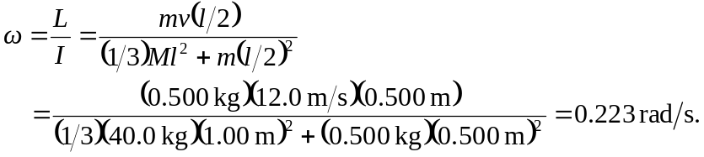

Ignoring the mass of the mud in the denominator of the above expression gives 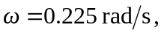 so the mass of the mud in the moment of inertia does affect the third significant figure.

